**VEHICLE MANAGEMENT SYSTEM**

INTRODUCTION:

* 1. Overview:

Vehicle fleet management is the process of overseeing all feet maintenance and fleet operations to help increase the business’s efficiency and minimize risk.

* 1. Purpose

To ensure the use of vehicle supports the university business in an efficient.

PROBLEM DEFINITION AND DESIGN THINKING:

2.1 Empathy Map

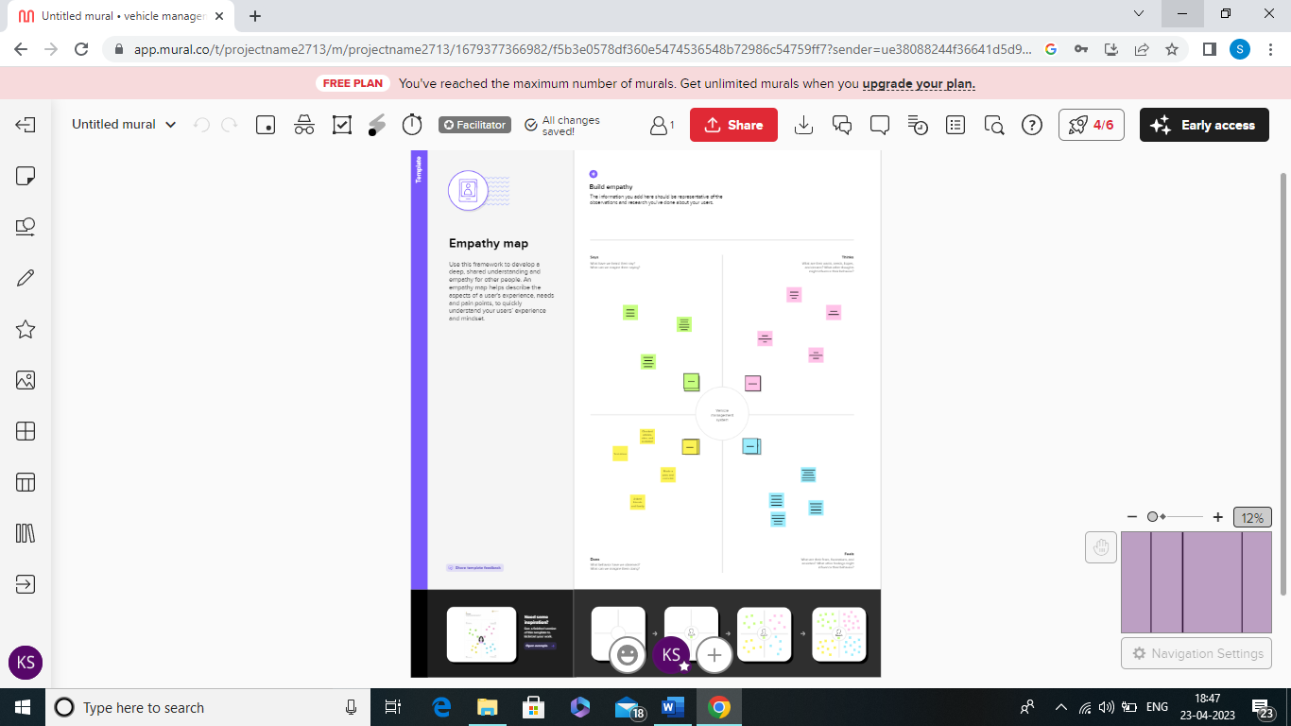

2.2 Ideation and Brainstorming Map

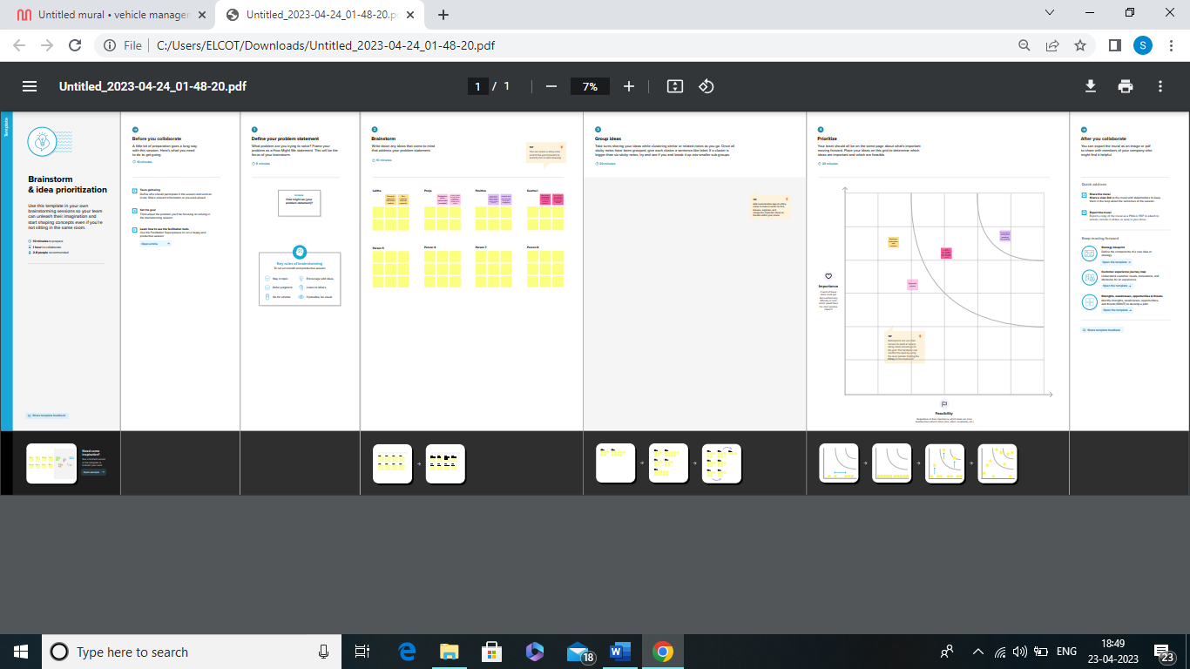

RESULT:

DATA MODULE:

Object 1

|  |  |  |
| --- | --- | --- |
|  |  |  |
| S no | Field names | Data types |
| 1 | Customer name | Text |
| 2 | Customer mobile number | Number |
| 3 | VEHICLE TYPE  2 wheeler  4 wheeler | Picklist |
| 4 | 2 WHEELER  Hero  Honda  Bajaj  Royal Enfield  TVS  Kinetic  OLA  JAWA  SD  Battery | Picklist |
| 5 | 4 WHEELERS  Renault  Skoda  Honda  Hyundai  Suzuki  Mahindra  Volkswagen  Benz  Audi  Volvo | Picklist |
| 6 | Vehicle name | Text |
| 7 | Vehicle number | Text |
| 8 | Chassic number | Text |
| 9 | Colour | Text |
| 10 | Body type | Text |
| 11 | VEHICLE INCLUDES  Fire extenuation  First aid kit  Multi changer kit  Stepney  Stereo  Tool kit  Tracking device  Tyre jack | Multi picklist |
| 12 | CONDITION  Good  medium  least | Picklist |
| 13 | Mileage | Text |
| 14 | Seats | Number |
| 15 | Start date | Date/time |
| 16 | End date | Date / time |
| 17 | Opportunity | Lookup(opportunity) |

Object 2

|  |  |  |
| --- | --- | --- |
| S no | Filed | Data type |
| 1 | Driver name | Text |
| 2 | Licence no | Text |
| 3 | Mobile no | Number |
| 4 | Air per hour | Text |
| 5 | Vehicle | Lookup(vehicle) |

ACTIVITY AND SCREENSHOT:

Activity 1

Creating developer account

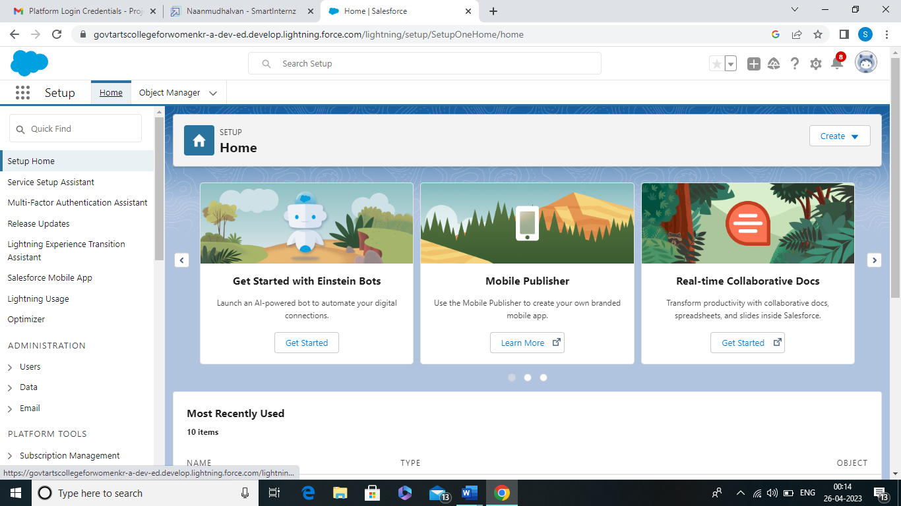

Milestone 2: object

Activity

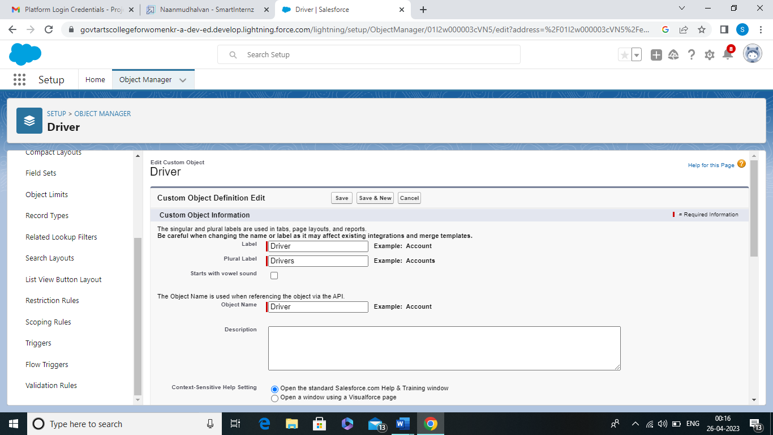

Milestone-3

Fields and Relationship

Activity

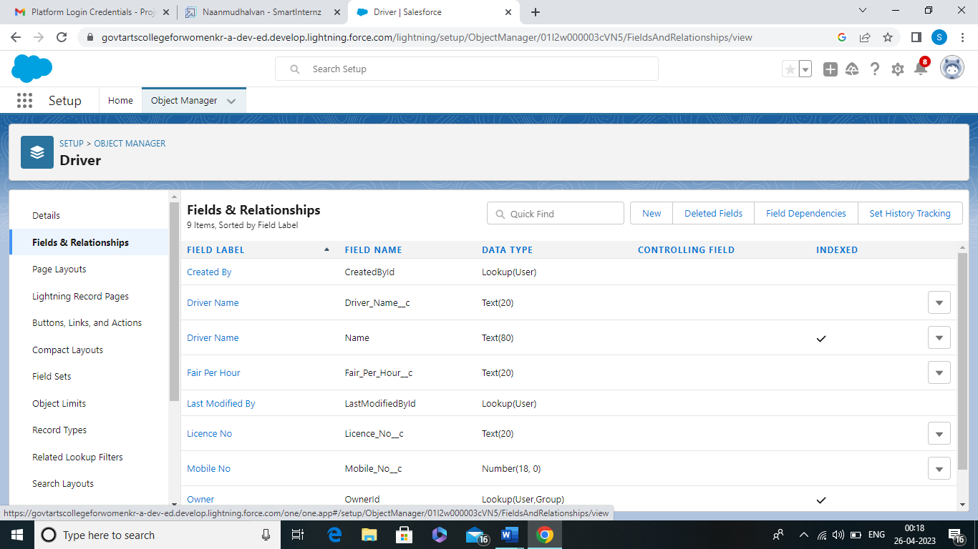

Milestone-4

Lightning App

Activity

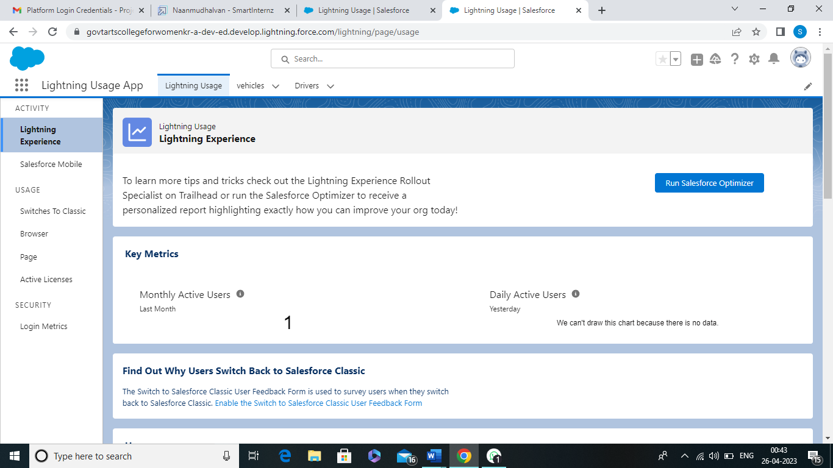

Milestone 5

Profile

Activity 1

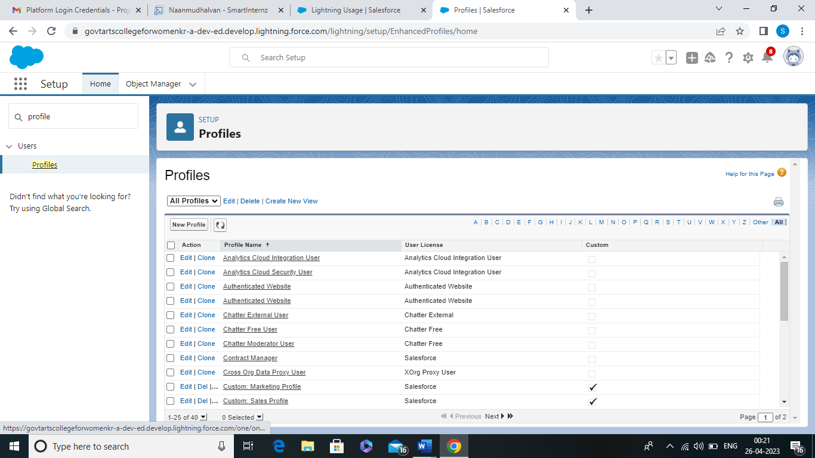

Milestone 6

Users

Activity

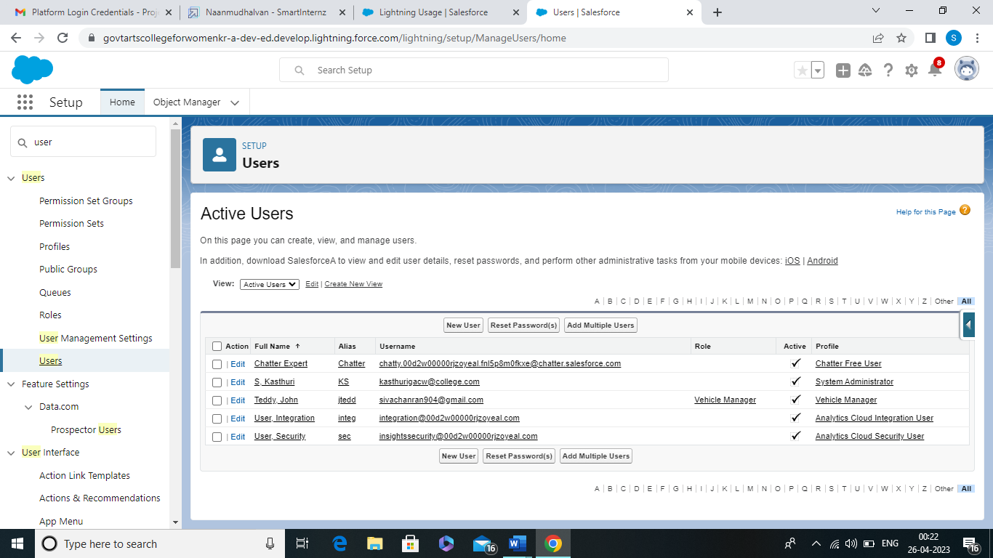

Milestone-7

Reports

Activity-1

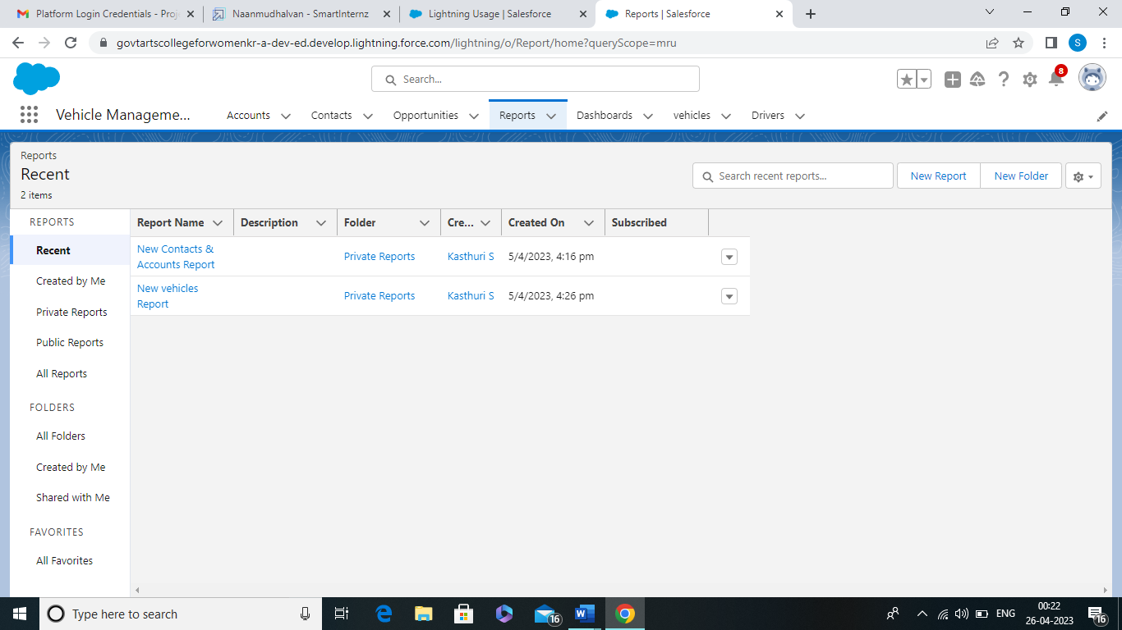

Activity-2

Dashboard

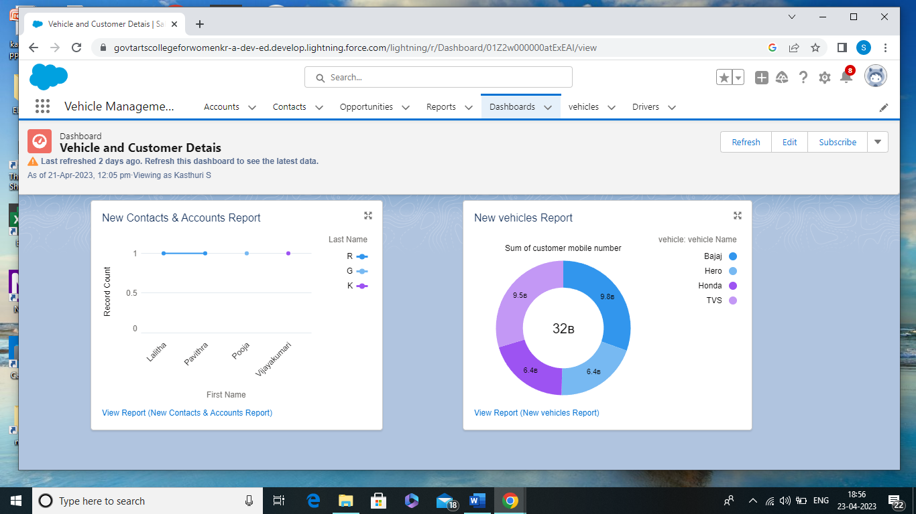

TRAIL HEAD PROFILE PUBLIC URL:

Team lead

<https://trailblazer.me/id/kasts1>

Team member 1

<https://trailblazer.me/id/llalitha12>

Team member 2

<https://trailblazer.me/id/ppavithra38>

Team member 3

<https://trailblazer.me/id/poojg7>

<https://drive.google.com/file/d/172ZvWJXFLLXxFJL73h50g-CzB_aj58te/view?usp=drivesdk>

ADVANTAGES AND DISADVANSTAGES:

Whoever is starting a fleet business wants to know everything about this business before he takes off. And one of the primary questions that lay in front of him is what are the advantages and disadvantages of vehicle management.

APPLICATIONS:

Facility areas

CONCLUSION:

The proposed vehicle system combines a positioning hardware, a communications platform that can be used to monitor and track a commuter transport in real time.

FUTURE SCOPE:

This document applies to all stop for salary sacrifice vehicles and authorised budget units for facility department vehicles and fleet hire purpose.